Problem Based Learning and Civic Engagement: Can connecting with community enhance the student learning experience?

Engagement by higher education with wider society takes many forms. It includes engagement with business and industry, with the civic life of the community, with public policy and practice, with artistic, cultural and sporting life and with other educational provider in the community and region, and It includes an increasing emphasis on international engagement. (Department of Education and Skills, 2011, p. 79.)

The ‘Just Imagine’ project by fourth year, level 8 students in Interior Architecture at Griffith College Dublin (GCD) was conceived to help each student achieve their best through individual effort by basing all projects within an inner-city Dublin neighbourhood. This project encouraged students to investigate the historic, social and economic aspects of a community as well as exploring the ideas of community, urbanism and the built environment.
The focus of this project is on how buildings within the existing built environment can be re-functioned or re-imagined for use both today and in the future. The project structure was designed in a way that would serve to foster student enthusiasm over the duration of the year, specifically to inspire a diverse body of students (both day and evening, Irish national and international) in their fourth and final consecutive year of study.
The project, or ‘Problem’, has been based within a specific geographical location, Dublin’s North East Georgian Quarter (NEGQ). This area encompasses the Summerhill and Sean McDermott Street areas in Dublin’s north inner city. By setting the project in a specific geographic area, we embraced “Place Based Learning and Civic Engagement” as a means for the student to explore beyond their academic environment out to the greater community, as a way of preparing them for entry into industry after graduation.
Watson (2003) allows that this form of civic engagement can provide a comprehensive and challenging vision, one that promotes a ‘’strenuous, thoughtful, argumentative interaction with a non-university world’’. Boland (2010) speaks of the emergent discourse of ‘active citizenship’ and of the inclusion of ‘insight’ as one of the eight dimensions in terms of which all awards are described within the National framework of Qualifications (www.nfq.ie). This specific project strengthened the students’ learning outcomes through the process of interacting with community, a process that created an awareness of civic engagement, through which the students gained a greater insight into the social implications of their chosen field of study and its potential for the future.
Boud and Felletti (1997) suggest that problem-based learning has been characterised as the most important innovation in education of the professions in the last few decades although Kirschner et al, (2006) is critical of this. In this paper, we will discuss how both points of view have informed the way this project is structured and illustrate how the project’s success has been informed by a combination of both arguments.

Current Literature
The current literature can be arranged into several strands. Several types of practice are merging together under what Clark (2008) refers to as a ‘Pedagogy for Civic Engagement’, which includes project work combined with place-based learning and civic engagement. This creates an opportunity for the student to enjoy what Barrett and Cashman (2010) calls a ‘journey of discovery’, in which a complex problem is embraced, one that is sufficiently open ended to allow for a variety of learning outcomes be explored and achieved. Several parts of this journey are discussed here.
A robust approach to primary research.
Oral History Project: In this project, we asked students to initiate a series of short, filmed interviews with people who had a connection with the building the student had selected. This interview was designed to form a base for further research by future students, and to preserve a document/record of who had contributed to the buildings today. These interviews would, in part, offer an idea of the state of the buildings’ interiors and how they are used (or not) today. The oral history component of the project comes on the recommendation of the European professional governing body, the European Council of Interior Architects (ECIA). During this phase of the project, students met with and documented the stories of architects, custodians, and local community users of their chosen building. These interviews provide an invaluable insight into how a specific building is understood by a community today, as well as how it might be best utilised in the future. Our stakeholders expressed admiration for the quality of the briefs that initiated the design process, which in turn grew out of this deep primary research.
Ethics in practice and social responsibility.
Bridging the gap between theory and practice was essential in order both to immerse the student in getting the most out of their final year of study, where research is crucial. It encouraged the application of this acquired information to their developing skill base in order to best prepare them to enter industry. Guerin and Hennessy (2010) argue that this enquiry-based learning approach helps students overcome the difficulties in linking theory and practice. Dodd (2007) suggests an important facet of this is information literacy, which is the ability to identify, find, evaluate and use information in an ethical way. In this project work, by clustering individual projects within a specific geographic area, the students were able to investigate not only what the buildings themselves could offer but also understand the impact their building-specific proposals might have on the wider community. It was important for students to become effective information seekers in order to successfully negotiate their way to these discoveries. Elrich (1999) believes that this approach is a ‘’powerful means both for teaching the strengths and pitfalls of democracy and for providing students with the foundations of democratic citizenship’’. He further offers that ‘’community outreach projects such as these create opportunities for four interrelated learning goals- academic learning, social learning, moral learning and civic learning and that civic learning is best achieved in concert with these other types of learning’’.
Collaboration and self-initiation
The student cohort on this project was diverse –in national origin, aptitude, and study mode, with students involved over a full-time day and part-time evening basis. Because of this, it was important to unite them and direct them all towards shared goals. The goals in this case were to achieve their best project outcome through self-motivation, information sharing and collaboration while taking their own, very individual ‘journey of discovery’. Their journey was framed using historical, contemporary, social, cultural and environmental themes. The project title: “Just imagine. Dublin’s lost or forgotten city quarter” proved irresistible to the students’ innate curiosity. The Irish students were familiar with old Dublin names such as the ‘Five Lamps’ and ‘The Monto’, which are a part of the city’s collective consciousness and have been articulated in song and verse. International students were intrigued by the wealth of fascinating historic buildings that currently required attention and intervention.
Each student negotiated an individual path through the research process and the practical application of the research to the design process. Students were asked to discuss and display their progress through a series of group and individual presentations. Kahn and O’Rourke (2005) advocate that responsibility falls to the student to analyse and present evidence in appropriate ways that supports their own approach to the problem.
Civic Engagement
Civic engagement was made easier by the response of the academic staff to the project proposal. The premise of a group project was provocative and allowed several of the other academic modules to be included in the project and assessed through the project and place-based learning. Clark (2008) confirms that ‘’It is well documented that when schools meaningfully connect learning to the local context through partnerships with local public lands, there is an increase in student engagement and enthusiasm. Likewise, it is accepted among educational professionals that when students are engaged and enthusiastic, their academic achievement improves.’’ By extending the project out to other organisations in the local area – The Five Lamps Festival (http://www.fivelampsarts.ie/), the VEC, Cluid Housing, Our Lady of Lourdes Catholic Church etc. – students were able to gain knowledge that would not have been apparent at first glance or from only classroom-based research. For example, one student was surprised to learn that not all change was welcome in the neighbourhood. Munck et al (2011) allow that ‘Human activity has a clear spatial as well as social dimension. Our social space in society is also a geographical space’.
The Five Lamps Festival is an annual festival of exhibitions and presentations about Dublin’s north inner city. It is named after a local landmark: an ornate cast iron Victorian lamp post. It is a community initiative and relies on volunteers for much of its success and is based in and around the North East Inner City. Participation over the week of the festival was valuable to students and the festival organizers alike. The festival’s date in April allowed it to be a part of the formative assessment schedule. Focused assessment is critical during this part of the project process. Price et al (2011) advise that ‘’learning is more effective when students understand the assessment process’’. A structured class plan that integrated the learning outcomes with required activities - excursions, field trips and exercises - was presented to students at the start and throughout the year, and emphasised the importance of participating in all of the above activities. The assessment breakdown was also discussed extensively at the start of the year. Curran (2010) explains that ‘’Assessment appears to be one of the main concerns of problem-based learning’’. Clear explanation of the breakdown is important in order to create a transparent and accessible assessment process. Exhibiting their project work at the Five Lamps Art Festival -- the neighbourhood where their proposed projects were located – became a cornerstone in the students’ assessment and civic engagement process. This presentation allowed for a preview of the projects in progress and gave the students a sense of impetus to the final deadline. The students left their work up for a week, allowing the public come to view it. Students also had to be present at the display, in groups, for the week, which allowed them to take in feedback from a range of stakeholders from community and industry. Barrett and Cashman (2010) said when ‘’designing problem-based initiatives it is important to have a range of stakeholders in designing problems that focus on key concepts and align with learning outcomes’’. Having the projects in progress on exhibit for a week, in a group environment, allowed for a thorough transparency of each students project. Detailed mark ups and feedback was successfully given to students during this week.
Transferable life skills
Throughout the year, the students developed key transferable skills for work and social life through their engagement with community and the world outside the campus, what Sobel (2004)refers to as an ‘’authentic environmental commitment emerges out of firsthand experience with real places’’. Clark (2008) states that participation in these projects has a lasting impact on students, which leads to a culture of volunteerism and stewardship, as well as building real solutions to local problems.
Methodology
In order to get a good overview of how the students experienced the project and how it was perceived by outside stakeholders, feedback was required. The following is a sample of the feedback, collected from various external stakeholders in the project, and also students who are represented in terms of qualitative and quantitative feedback. Qualitative feedback was also given from three other stakeholders - one from industry, one from the community, and our external assessor. The qualitative comments shared by the students are included under the graphs of the questions selected to illustrate the feedback. The feedback and charts below are based on an online survey that 55% of the students responded to.
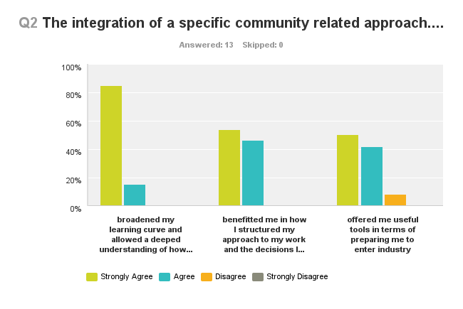
Regarding integration of assessment with a community-based project: There was a strong indication that this helped the students achieve a deep level of understanding and served to guide and instruct the students through the year to prepare them for their professional life. From the above chart:
Part 1: The integration of a specific community related approach broadened my learning curve and allowed a deeper understanding of how my work may address larger social issues.
All students responded positively to the organised tour and talks with community leaders and historians. Historical and contemporary explanations blended to give strong background to the project. These were particularly helpful in assisting students in fleshing out their briefs/problems. Two students won awards for their work. One achieved best student in her category in the 2013 Institute of Designers in Ireland national student awards.
Part 2: The integration of a specific community related approach benefited me in how I structured my approach to my work and the decisions I made in terms of best meeting my learning out comes.
The structuring of the research, both primary and secondary, was considered very valuable in tandem with the learning outcomes. E.g. evaluate and defend proposals from an informed position with regard to site context, building use, branding opportunities and urbanism. Recording local input, through the use of oral histories, allowed students to defend their proposals from a very real and informed position, thus empowering their presentations.
Part 3: The integration of a specific community related approach offered me useful tools in terms of preparing me to enter industry.
As part of the assessment criteria students were encouraged to expand beyond the campus, to interview within the community and participate at local events such as the Monto walking tour and the Five Lamps Festival. This was part of a process to bridge the gap between the academic environment and industry.

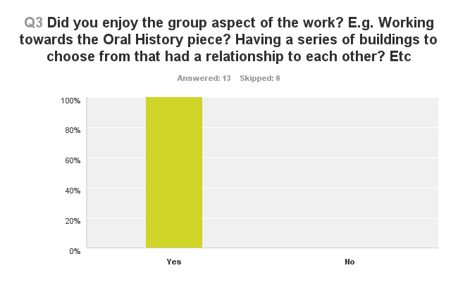
Regarding the group work: there was an overwhelmingly favourable response to the relationship between all individual projects and how a group effort impacted the overall group structure. Feedback indicated that this should happen earlier in the year so as to allow for a greater degree of influence in their final design project.
Student Comments:
- Yes I thought it was great that there was a sense of team work between students especially in that we could help one another out with photos etc due to the fact that our projects were based in the same area.

- This I think should be done sooner. After the student has researched the area and the building, in order to have valued questions.

- Should have started and finished the oral history project earlier.

- However, I think that each student should have their own person to interview and their own building. This would make the project more unique. Also oral history assignment should be better organized, it was rushed and we got very little help from tutors in organizing this.

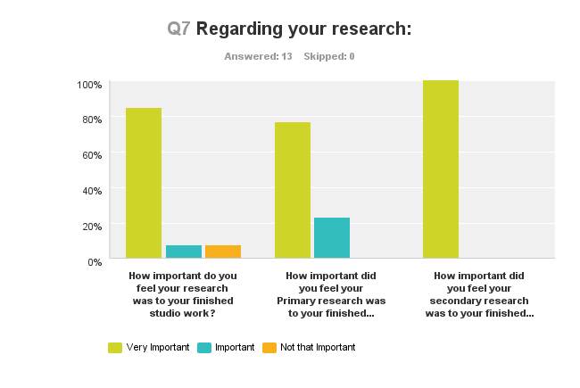

Question 7. Regarding Research: All students considered their research as a crucial part of their project success. However, some may not have been comfortable being forced into the primary research part, including the one to one interviews. The orange represents some level of discomfort here. However, the over all in green/blue is very positive.

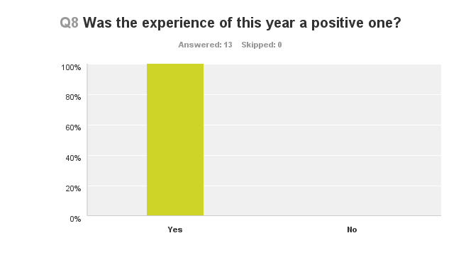
It is encouraging that all students who did the survey (it represents 55% of the class) found the process, project and year a positive experience.

Student Comments:

- Without a doubt this year was a very positive experience. I learned more this year than any other year and I feel that my skills developed more rapidly this year.

- I really enjoyed this year, after having a very tough third year. I thought the course layout was excellent and very exciting. I have learned so much, and believe that my abilities and design style has improved greatly throughout the year. I have learned to have fun, and work hard. John is a credit to Griffith College, and I can say that I would not have got through it without him. So thank you John, I had a wonderful 4th year experience :)

- Without a doubt this year was a very positive experience. I learned more this year than any other year and I feel that my skills developed more rapidly this year.

Qualitative feedback: the following are some comments from a variety of stakeholders in the project process and demonstrate the positive way in which the project was externally perceived as a learning experience.
Peter Dixon (Leeds University) External Examiner to the programme
Links with industry are strong. The continued CPD workshops upkeep and further develop a positive link to the industry and in particular to suppliers. The resource of the sample room is encouraging as long as it can be updated and managed effectively, which is recognised as no easy feat. The final year students in particular take full advantage of samples available from the in house store. With the adoption of the hugely effective Georgian quarter final year project, it was evident that many of the briefs were being driven from the research gathered from their site and surrounding area, It was evident in many cases that this context guided the briefs with local history and the site specific references informing the direction and development of the brief. This should be further encouraged and one imagines as the knowledge of the area grows and an archive born, this will become richer.
Charles Duggan (Dublin City Council) Heritage Officer
This is a very interesting project by Griffith College and I have had some contact with students of the course in the past and partnering them with a building - and the results were certainly thought-provoking.
Arthur Duff (The Malt house Design Practice), community resident and business owner
...as a way of structuring learning experience I think it is very creative and appropriate at this stage in their studies. It is a very good way of grounding their design capacity in what is the real world with real people for clients / end users. Of course some of the students were too ambitious in their choice of projects - not a fault as such but perhaps there could be an argument for taking much smaller project that could be the opportunity for a more considered design response. Understanding limits is key in the process of creating viable design solutions. I thought the interaction of the students with the communities related to their projects was very stimulating as well as the chance for some of them to work with each other or parallel with each other.
Analysis
A further analysis of the information given by the students demonstrates they were very positive about how their year progressed. All of them agreed that the level of civic engagement improved their learning process. All of the students enjoyed and benefitted from the group dynamic. In terms of the application of research to their final work, all students achieved a strong understanding of the benefits of thorough research, both primary and secondary. There was a strong bond between groups, day and evening. Several strands of research overlapped and bonds were formed easily through the shared interest. As Curran (2010) describes, usually there is a period of adjustment as a group dynamic is formed, the “forming, storming, norming etc”. However, in this group each team member immediately engaged deeply with their research and the subsequent application of this to their project work. One student mentions this in terms of the ‘insight’ they felt they achieved:
It was a challenge at first, as I had thought about what I might do for my final year project throughout the summer, knowing what might be ahead from previous years. As far as the studio work, I wouldn't have changed any aspect, the familiarity of the area brought all of us as a class with a better insight, and we were able to support each other through design decisions as we were much more involved as a group.

Curran (2010) also speaks of the schedule of learning activities: that their ‘’challenge membership management committee strongly encourages each team member to pay close attention’’. The ‘Just Imagine’ project was strongly structured with a series of assessments within the main studio project work with a combination of traditional lectures. 2nd and 3rd year students supported the final year students in their work initially (as part of a vertical project) and were graded by the 4th year students on this. This allowed the final year students a practical engagement with the learning outcomes and associated assessment process by them (for others) in the early parts of the year. This embedded an understanding of what was required in various assessment stages throughout the year.
The project stakeholders all agreed in how the place-based learning inspired a common sense of purpose. The accumulation of the work into a published graduate year book and a presentation of the collective projects were very well received when the exhibition was launched locally by the Minister for Education and Skills, Ruari Quinn. Tipton, G. previewed the exhibition in The Irish Times (05 09 13) and noted that while “Patterns of ownership change, social policy shifts, politics fail but these projects show how interventions, whether large or small, on our current architectural stock could change the fortunes of the whole area for the better”. Savery et al (1995) describes anchoring all learning activities to a larger task or problem (in this case a socio-economic, as well as environmental, one) allowed for good results across the board.
External examiner, Peter Dixon commented, ‘’what stands out, compared to many similar programs, is that GCD interiors team are able to achieve high standards across the whole cohort, this should be applauded.’’
Interpretation
The project process has been guided, in part, by the initiative from the Government encouraging academic institutions to engage with their communities. “Engagement with the community is seen as particularly important in the context of its promotion of greater equality in higher education.” (Department of Education and Skills, 2011).

This initiative has formed the genesis of the project. The following is a reflection on the process.
Student Engagement: The structured, problem-based learning approach, one based in in a place or community, created a sense of curiosity within the student group that was integral to generating and maintaining the students’ focus. The integration of primary research and community-embedded project work, guided by transparent criteria for assessment, created a momentum that carried the class through the various stages of the project. All members of the student group benefited from this integrated structure. Von Glaserfeld (1989) notes, “Other people are the greatest source of alternate views to challenge our current views and hence to serve as the source of puzzlement that stimulates new learning”.
Early Intervention: The best projects were those that grew from strong student briefs. These projects were based on answers the students received from community-focused research, which in turn were based on the guidelines issued as part of the project kickoff. These project briefs or ‘problems’– realistic suggestions for new functions for existing under-used buildings within a given area – were grounded in the community and appropriate for the individual buildings selected.
The winner of the Best Student Award, sponsored by The Malt House, went to a student who gained inspiration from her own family’s business and who proposed a solution built from this. Her project, Summer Hill Bakery — a bakery and cooking school created to serve the greater area – was designed to offer employment to the community and draw new users into the area, which fully realised the three benchmarks of the initial brief given to all students.
The winner of the Institute of Designers in Ireland Best Interior Architecture Student Project for 2013 was awarded to a student who responded to the needs of emerging immigrant communities in the area.
The briefs were authored by the students and they were guided through a structured research process under the direction of several fourth-year tutors. Dodd (2007) reiterates that ‘’the development of generic skills is often cited as one of the benefits of introducing both enquiry and problem based learning. One of these is information literacy, which is the ability to identify find, evaluate and use information in an ethical way’’. By evaluating relevant community, economic and social data, students were able to achieve a deeper engagement with their work, one that carried their momentum through to the end of year. Dodd (2007) also states ‘’Integrating information literacy into the curriculum is the most effective way to allow students to develop these skills’’. Cusack (2010) says that this level of information literacy ‘’the ability as a group to decide on how they would best achieve their own learning outcomes’. Finally, the brief provided a strong starting point but yet was open enough to allow the students to graft their own sense of ownership onto it. Savery and Duffy (1995) reinforce this idea stating ‘’If the students are to engage in authentic problem solving, then they must own the problem’’.
Emotional Investment: Within this project structure, there was a great level of emotional investment – on behalf of the students individually and as a group – that allowed for the students to gain a greater degree of insight into their projects. A number of the academic staff expressed that this emotional investment was a benefit to their own teaching also and of how it further engaged the students in areas outside of their individual projects. Savery and Duffy (1995) allow that no matter what we, as teachers, specify as the learning objective, the goals of the learner will largely determine what is learned. Hence, it is essential that the goals the learner brings to the academic environment be consistent with the instructional goals.
A Structured Learning Environment: Feedback from the students provides some interesting observations. There was a very high satisfaction level with how the research was integrated into the project work. Also, student feedback provided support for using a good integration of problem-based learning reinforced by traditional lecture-based delivery with a scaffold of regular assessment and feedback. The benchmarks for this are strong class planning with well-defined, transparent assessment after each interim crit. Aulls (2002) describes ‘’the scaffolding that the most effective teachers introduced when students failed to make learning progress in a discovery setting’’. He reported that the teacher whose students achieved all of their learning goals spent a great deal of time in instructional interactions with students.
In addition to the above, staff and students organised Continued Professional Development seminars (CPDs) whereby suppliers and experts from industry were invited into the class to present. Teams of students were organised by the tutor and required to invite and co-ordinate the delivery of these CPDs to the class through the year. This is not new thinking. Dewey (1938) emphasizes the importance of students learning outside of the classroom and their ability to make connections between the classroom and real world applications in the everyday community.
Going Forward
In considering future improvement for this project, it is important to address the issues of the scale of projects that the students work on.
All strands of the research need to be front loaded to allow for greater impact in the design development process.
It is important for the tutors to emphasise the specific areas of detail that the students must be engaged during the second part of the academic year once research is complete.
Final communication of the project, presentation and an allowance for a corrective, final reflection on the process needs to be further emphasised.
Finally, it would be advisable for future groups to continue to implement the use of scaled, three-dimensional models – in static and in animated form – as these are critical to promoting the project work. This year, these models proved very popular in enabling people from outside the industry to actively and productively engage with the projects, and their stories, during public exhibitions.

Conclusions
To summarize, problem/place-based learning is well suited to the delivery of this project. It has allowed for a strong incorporation of civic engagement that fits well with the goal of community outreach as directed by government. The specific project challenges -- assembled by the students, and guided by the tutor – are well suited to nurturing the students’ transition from the academic environment to industry.
A cohesive faculty commitment to the student projects, if successfully initiated by the team leader or year head, and taken on board in a positive fashion by most of the year’s teaching staff, will benefit the students who in turn should continue in a similar fashion to achieve a deep, committed level of engagement with their subject.
Engagement with the community is particularly important in the context of its promotion of greater equality in higher education.

While recognizing that community engagement has a long history, it has been argued that “this has not been as coordinated as it might be and in the future this needs to be developed more ﬁrmly as the core mission of higher education in Ireland. (Department of Education and Skills, 2011, p.77).

Problem-based learning and civic engagement are best achieved through a successful structuring of the year through the delivery of modules in a traditional lecturing/delivery based around a central problem-based learning question. This scenario can achieve strong results across a wide range of student aptitude.

If you don’t know where you are, you don’t know who you are.
Wallace Stegner

References
Aulls, W.M. (2002) ‘The contributions of co-occurring forms of classroom discourse and academic activities to curriculum events and instruction’, Journal of Educational Psychology, 94, pp. 520 538.
Barrett, T. (2003) ‘What is problem-based learning?’ [Online]. Available at: http://www.aishe.org/readings/2005-1/barrett-What_is_Problem_B_L.pdf (Accessed: 15 July 2013).
Barrett, T., and Cashman, D. (2010) A practitioner’s guide to enquiry and problem-based learning: case studies from University College Dublin. [Online]. Available at: http://www.ucd.ie/t4cms/ucdtli0041.pdf (Accessed 19 August 2013).
Boud, D. and Felletti, G. (1997) The challenge of problem-based learning. London: Kogan.

Barrow,H., and Tamblyn,R. (1980) Problem-based learning: an approach to medical education. Springer Publishing Co. USA.
Boland J, (2008) Embedding a civic engagement dimension within the Higher Education curriculum: a study of Policy.
Boland J. (2010) Teaching and learning through civic engagement: prospects for sustainability in teacher education.
Boyer, E. L., and Mitgang, L. D. (1996) Building Community: A New Future for Architecture Education and Practice: A Special Report. California, Princeton Fulfilment Services.
Clark, D. (2008) Learning to make choices for the future. Connecting Public lands, Schools and communities through Place-based learning and Civic Engagement. The Centre for Place Based Learning and Community Engagement.
Clarke, D. (2010) ‘Engaging 500 first year students of English through enquiry based learning’. [Online]. Available at: http://www.ucd.ie/t4cms/ucdtli0041.pdf (Accessed: 15 July 2013).
Curran, T. (2010) ‘Hands on’ Experience in the PBL biosystems engineering design challenge’. [Online]. Available at: http://www.ucd.ie/t4cms/ucdtli0041.pdf (Accessed: 30 September 2013).
Cusack, T. (2010) ‘Inter-care professionalism in health care education’. [Online]. Available at: http://www.ucd.ie/t4cms/ucdtli0041.pdf (Accessed: 19 August 2013).
Carrington C. (2010) ‘Integrating and applying key knowledge through problem-based learning modules’. [Online]. Available at: http://www.ucd.ie/t4cms/ucdtli0041.pdf (Accessed: 15 July 2013).
Department of Education and Skills. (2011) ‘National Strategy for Higher Education to 2030.’ [Online. Available at: http://www.hea.ie (Accessed: 15 July 2013).
Delisle R. (1997) How to use problem based learning in the classroom. Alexandria, Virginia.
Dewey, J. (1938) Logic: the theory of inquiry. New York: Holt and Co.
Dodd, L. (2007) ‘The impact of problem-based learning on the information seeking behaviour and information literacy of veterinary medicine students at University College Dublin’, Journal of Academic Librarianship, 33(2), pp. 206-216.
Ehrlich, T. (1999). ‘Civic education: lessons learned’, PS Political Science and Politics, 32(2), pp. 245-250.
Guerin, S. and Hennessy, E. (2010) ‘Linking theory to practice in applied developmental psychology using enquiry-based learning’. [Online]. Available at: http://www.ucd.ie/t4cms/ucdtli0041.pdf (Accessed 19 August 2013).
Kahn, P. and O’Rourke, K. (2005) ‘Understanding enquiry based learning’. [Online]. Available at: http://www.aishe.org/readings/2005-2/chapter1.pdf (Accessed: 30 September 2013).
Kirschner, P. A., Sweller, J., and Clark, R. E. (2006) ‘Why minimal guidance during instruction does not work: An analysis of the failure of constructivist, discovery, problem-based, experiential, and inquiry-based teaching’, Educational Psychologist, 41(2), pp. 75-86.
McIlrath, L., Lyons, A., and Munck, R. (2012) ‘Mobility of Eastern European citizens: training and development’, European Journal of Training and Development, 37(8), pp.766 – 778.
Munck, R., McQuillan, H., and Ozarowska, J. (2011) ‘Civic engagement in a cold climate: a global perspective’. [Online]. Available at: https://www4.dcu.ie/sites/default/files/community/docs/Chapter1.pdf (Accessed 30 September 2013).
Price, M., Carroll, J., O'Donovan, B. and Rust, C. (2011) 'If I was going there I wouldn't start from here: a critical commentary on current assessment practices', Assessment & Evaluation in Higher
Education, 36 (4), pp. 479-492.

Savery, J. R., and Duffy, T. M. (1995) ‘Problem based learning: an instructional model and its constructivist framework’, Educational Technology, 35(5), pp. 31-38.
Savery, J. R. (2006) ‘Overview of problem-based learning: deﬁnitions and distinctions’, Interdisciplinary Journal of Problem-based Learning, 1(1), pg.3.

Tipton, G. (2013) ‘Rethinking Dublins North Inner city’ Irish Times Sept 05 2103 P.14

Watson, D. (2003) ‘The university in the knowledge society’, in Bjarnson, S. and Copldstream, P. (eds.) The idea of engagement: universities in society. London: Association of Commonwealth Universities.
Von Glaserfeld, E. (1989) ‘Cognition, construction of knowledge and teaching’, Synthese, 80, pp. 121-140.
Web:
Place Based Education Project (2006) www.peecworks.org/PEEC/PEEC_Reports/S01248363-01267A71 (Accessed: 15 July 2013).
The Center for Place-based Learning and Community Engagement (2008) Learning to Make Choices for the Future. Available at:
http://www.ntu.edu.vn/Portals/96/Tu%20lieu%20tham%20khao/Phuong%20phap%20giang%20day/place-based%20learning.pdf (Accessed: 19 September 2013).
Nelson, Katherine (2010) ‘The Influence of Outdoor and Environmental Education on
Student Engagement and Achievement in Science’. Available at: http://www.smcm.edu/educationstudies/pdf/rising-tide/volume-3/katherine-nelson-mrp.pdf (Accessed: 5 September 2013).
University of Michigan--Ann Arbor, Place-Based Education Wiki Page. Available at: http://edreformsectionb.wikispaces.com/Place+Based+Education (Accessed: 19 September 2013).
National Framework of Qualifications. Available at: http://www.nfq.ie/nfq/en/ (Accessed: 19 August 2013).
Bradford University (2012). ‘The Case for Programme Focused Assessment‘ . Available at: http://www.pass.brad.ac.uk/position-paper.pdf (Accessed: 30 September 2013).

